Test report with Results of manual tests execution

Execution Date: 24/05/20

“White Stormers”

Ihor Kozlov

**List of Team members:**

### Khrystyna Shapovalova,

### Anastasiia Knysh,

### Dasha Ogulia,

### Kozlov Ihor.

**Functional areas that were tested:**

1. Registration page.
2. Products favorite page.
3. Reset Password page.
4. Products listing page.
5. The count input element on the shopping cart page.
6. Product details module.
7. Log in form.
8. The mini-cart pop-up.
9. The Quick View Module.
10. Upsell module.
11. The Comparison module.
12. The Product details module.
13. The Notification module.
14. The Checkout module.
15. The Zoom module.

***Test execution results:*** 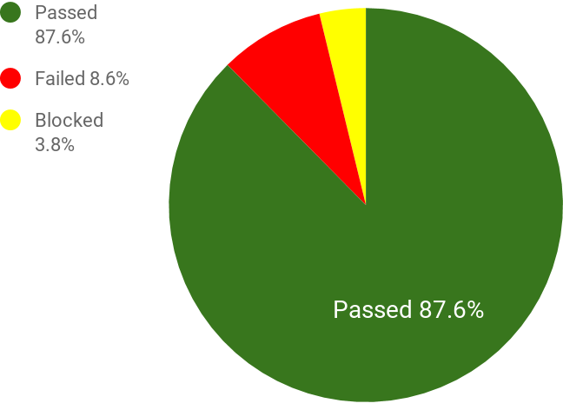

|  |  |  |
| --- | --- | --- |
| Overall | 105 | 100% |
| Passed | 92 | 87.6% |
| Failed | 9 | 8.6% |
| Blocked | 4 | 3.8% |
| Not Executed | 0 | 0% |

**Quality Level = 87.6%**

***Time used for executing 105 test cases (hours): 6 hours***

***List of Executed Test Cases:***

|  |  |
| --- | --- |
| FK-9 | Successfully passed |
| FK-12 | Mistake in the understanding of requirements:  Requirements unknown |
| FK-15 | Successfully passed |
| FK-19 | Successfully passed |
| FK-21 | Successfully passed |
| FK-22 | Successfully passed |
| FK-24 | Successfully passed |
| FK-27 | Error in precondition: We don't have products to compare. |
| FK-29 | Successfully passed |
| FK-31 | Successfully passed |
| FK-32 | Successfully passed |
| FK-34 | Successfully passed |
| FK-35 | Error in step 1: We don't have button "Back to browsing" |
| FK-68 | Successfully passed |
| FK-69 | Successfully passed |
| FK-70 | Successfully passed |
| FK-71 | Successfully passed |
| FK-72 | Successfully passed |
| FK-73 | Successfully passed |
| FK-74 | Successfully passed |
| FK-75 | Successfully passed |
| FK-76 | Successfully passed |
| FK-77 | Successfully passed |
| FK-86 | Successfully passed |
| FK-87 | Successfully passed |
| FK-88 | Successfully passed |
| FK-89 | Successfully passed |
| FK-90 | Successfully passed |
| FK-91 | Successfully passed |
| FK-92 | Successfully passed |
| FK-93 | Successfully passed |
| FK-94 | Successfully passed |
| FK-95 | Successfully passed |
| FK-96 | Successfully passed |
| FK-97 | Successfully passed |
| FK-100 | Successfully passed |
| FK-107 | Successfully passed |
| FK-108 | Successfully passed |
| FK-109 | Successfully passed |
| FK-110 | Successfully passed |
| FK-111 | Successfully passed |
| FK-112 | Successfully passed |
| FK-113 | Successfully passed |
| FK-114 | Successfully passed |
| FK-115 | Successfully passed |
| Fk-116 | Successfully passed |
| FK-117 | Successfully passed |
| FK-118 | Successfully passed |
| FK-132 | Successfully passed |
| FK-136 | Successfully passed |
| FK-139 | Bug FK-316 reported |
| FK-143 | Successfully passed |
| FK-145 | Mistake in the understanding of requirements:  Workflow is different for adding item to the cart from Quick View modal |
| FK-148 | Successfully passed |
| FK-150 | Successfully passed |
| FK-151 | Successfully passed |
| [FK-155](http://lab.forteknowledge.com:8080/browse/FK-155) | Successfully passed |
| [FK-157](http://lab.forteknowledge.com:8080/browse/FK-157) | Successfully passed |
| [FK-158](http://lab.forteknowledge.com:8080/browse/FK-158) | Successfully passed |
| [FK-159](http://lab.forteknowledge.com:8080/browse/FK-159) | Successfully passed |
| [FK-160](http://lab.forteknowledge.com:8080/browse/FK-160) | Successfully passed |
| [FK-162](http://lab.forteknowledge.com:8080/browse/FK-162) | Can`t entered more then 8 characters in password field |
| [FK-163](http://lab.forteknowledge.com:8080/browse/FK-163) | Successfully passed |
| [FK-165](http://lab.forteknowledge.com:8080/browse/FK-165) | Successfully passed |
| FK-166 | Can`t see the message that the link for password reset has expired: "Reset password link was expired due to disuse. Please submit new forgot password request. |
| [FK-169](http://lab.forteknowledge.com:8080/browse/FK-169) | Can`t see the message that the link has already been used for successful password reset: "You already has changed your password. To reset password, please subr forgot password request" |
| [FK-190](http://lab.forteknowledge.com:8080/browse/FK-190) | Successfully passed |
| [FK-191](http://lab.forteknowledge.com:8080/browse/FK-191) | Successfully passed |
| [FK-192](http://lab.forteknowledge.com:8080/browse/FK-192) | Successfully passed |
| [FK-193](http://lab.forteknowledge.com:8080/browse/FK-193) | Successfully passed |
| [FK-194](http://lab.forteknowledge.com:8080/browse/FK-194) | Successfully passed |
| [FK-195](http://lab.forteknowledge.com:8080/browse/FK-195) | Successfully passed |
| [FK-196](http://lab.forteknowledge.com:8080/browse/FK-196) | Successfully passed |
| [FK-197](http://lab.forteknowledge.com:8080/browse/FK-197) | Successfully passed |
| FK-198 | Successfully passed |
| [FK-199](http://lab.forteknowledge.com:8080/browse/FK-199) | Successfully passed |
| FK-219 | Successfully passed |
| FK-220 | Successfully passed |
| FK-221 | Successfully passed |
| FK-222 | Successfully passed |
| FK-223 | Successfully passed |
| [FK-224](http://lab.forteknowledge.com:8080/browse/FK-224) | Successfully passed |
| [FK-225](http://lab.forteknowledge.com:8080/browse/FK-225) | Can't continue login with entered incorrect address information which can be refined by AVS. System don`t offer a user to continue with entered information |
| [FK-226](http://lab.forteknowledge.com:8080/browse/FK-226) | Successfully passed |
| [FK-227](http://lab.forteknowledge.com:8080/browse/FK-227) | Successfully passed |
| [FK-228](http://lab.forteknowledge.com:8080/browse/FK-228) | Successfully passed |
| [FK-229](http://lab.forteknowledge.com:8080/browse/FK-229) | Error: Absence “Click here” button |
| [FK-230](http://lab.forteknowledge.com:8080/browse/FK-230) | Successfully passed |
| FK-239 | Successfully passed |
| FK-244 | Successfully passed |
| FK-247 | Successfully passed |
| FK-250 | Successfully passed |
| FK-252 | Successfully passed |
| FK-253 | Successfully passed |
| FK-254 | Successfully passed |
| FK-255 | Error in steps 3 and 4: We don't have field “"Email me when this item  is in stock", and button “Submit Email” |
| FK-285 | Successfully passed |
| FK-286 | Successfully passed |
| FK-287 | Successfully passed |
| FK-288 | Successfully passed |
| FK-289 | Successfully passed |
| FK-290 | Successfully passed |
| FK-291 | Successfully passed |
| FK-292 | Successfully passed |
| FK-293 | Successfully passed |
| FK-307 | The scroll is displayed in the mini-cart pop-up after adding four items |
| FK-308 | Ability of end-user to continue shopping from comparison page |
| FK-316 | Ability of a user to view Quick View modal on cross-sells and up-sells area of the product details page |

***Amount of issues (bugs) that were found:***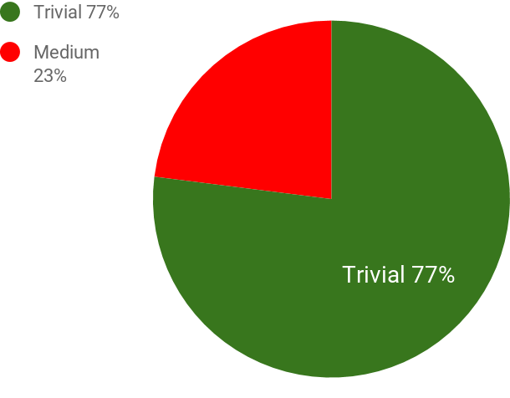

|  |  |  |
| --- | --- | --- |
| Overall | 9 | 100% |
| Trivial | 7 | 77% |
| Medium | 2 | 23% |
| Major | 0 | 0% |
| Blocker | 0 | 0% |

***List of Bug Reports:***

|  |  |  |
| --- | --- | --- |
| ID | Severity | Summary |
| FK-27 | Trivial | Ability of end user to delete all product from comparison on Comparison Page |
| FK-35 | Trivial | Ability of end user to continue shopping from comparison page |
| FK-162 | Trivial | Can`t entered more then 8 characters in password field |
| FK-225 | Trivial | Can't continue login with entered incorrect address information which can be refined by AVS. System don`t offer a user to continue with entered information |
| FK-307 | Trivial | The scroll is displayed in the mini-cart pop-up after adding four items |
| FK-308 | Trivial | Ability of end-user to continue shopping from comparison page |
| FK-316 | Trivial | Ability of a user to view Quick View modal on cross-sells and up-sells area of the product details page |
| FK-166 | Medium | Can`t see the message that the link for password reset has expired: "Reset password link was expired due to disuse. Please submit new forgot password request. |
| FK-169 | Medium | Can`t see the message that the link has already been used for successful password reset: "You already has changed your password. To reset password, please subr forgot password request" |

**Conclusion:**

Nine bugs. It’s not normally for a stable version, but 7 bugs only have trivial severity, and 2 bugs medium severity. With this functionality our store can work very well.

For next Sprint i would recommend to improve the process of communication between all people in this project.

**Test Suite 1. Executed by Khrystyna Shapovalova.**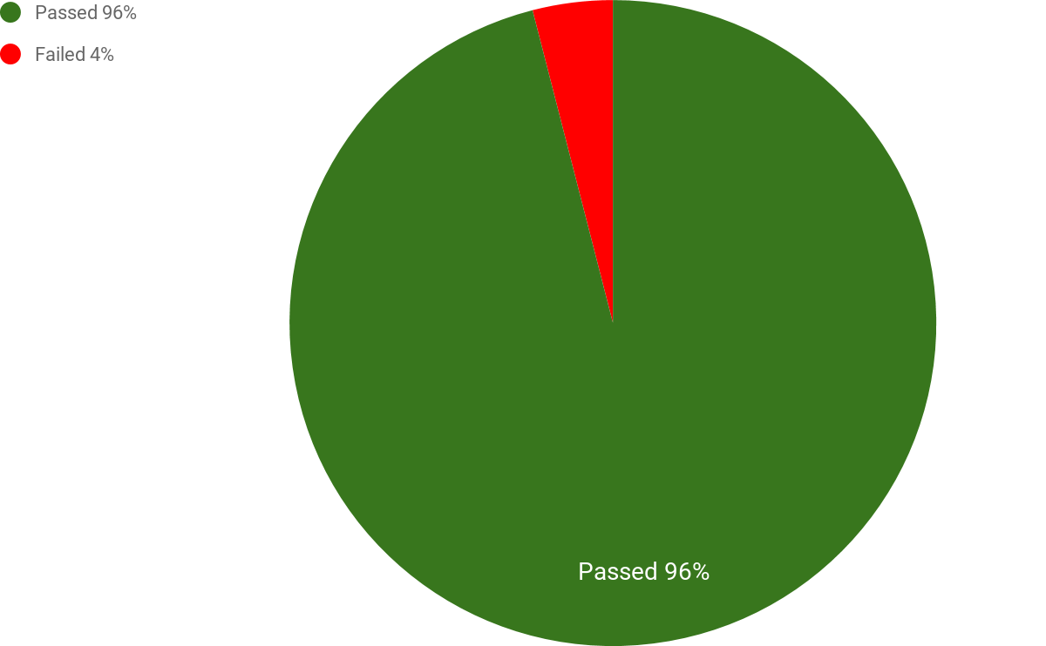

***Test results:***

|  |  |
| --- | --- |
| Overall | 24 / 100% |
| Passed | 23 / 96% |
| Failed | 1 / 4% |
| Blocked | 0 / 0 % |
| Not Executed | 0 / 0% |

***Time used for executing 24 test cases (hours): 1 hours***

***Issues that were found (1):***

|  |  |  |
| --- | --- | --- |
| ID | Severity | Summary |
| FK-307 | Low | The scroll is displayed in the mini-cart pop-up after adding four items |

**Conclusion:**

One bug. It’s normally for stable version.

For the next Sprint, I would recommend improving the process of updating test cases with the Traceability Matrix. It allows us to identify the test cases which need to be updated in case of changes in requirements. That means it will decrease the time to execute test cases.

**Test Suite 2. Executed by Anastasiia Knysh.**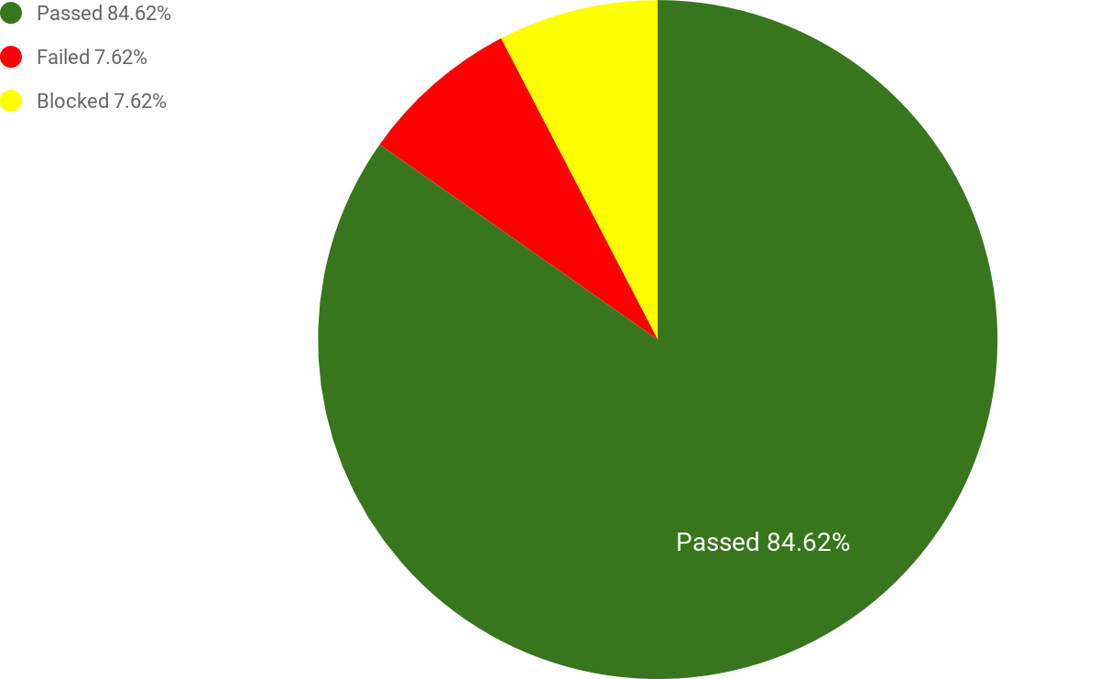

***Test results:***

|  |  |
| --- | --- |
| Overall | 26 / 100% |
| Passed | 22 / 84.62% |
| Failed | 2 / 7.69% |
| Blocked | 2 / 7.69% |
| Not Executed | 0 / 0% |

***Time used for executing 26 test cases (hours): 2.5 hours***

***Issues that were found (2):***

|  |  |  |
| --- | --- | --- |
| ID | Severity | Summary |
| FK-316 | Trivial | Ability of a user to view Quick View modal on cross-sells and up-sells area of the product details page |
| FK-308 | Trivial | Ability of end-user to continue shopping from comparison page |

**Conclusion:**

A few bugs were found, it’s normally for a stable version.

**Test Suite 3. Executed by Daria Ohulia**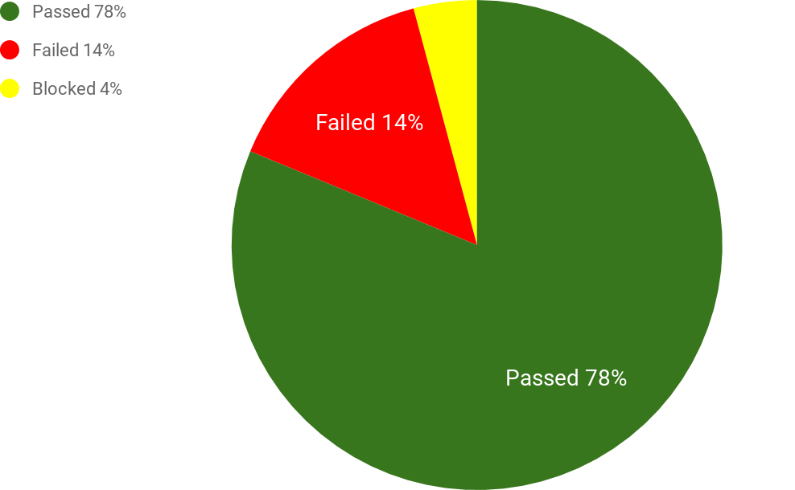

***Test results:***

|  |  |
| --- | --- |
| Overall | 27 100% |
| Passed | 22 / 78% |
| Failed | 4 / 14% |
| Blocked | 1 / 4% |
| Not Executed | 0 / 0% |

***Time used for executing 26 test cases (hours): 1.5 hours***

***Issues that were found (4):***

|  |  |  |
| --- | --- | --- |
| ID | Severity | Summary |
| FK-225 | Trivial | Can't continue login with entered incorrect address information which can be refined by AVS. System don`t offer a user to continue with entered information |
| FK-162 | Trivial | Can`t entered more then 8 characters in password field |
| FK-166 | Medium | Can`t see the message that the link for password reset has expired: "Reset password link was expired due to disuse. Please submit new forgot password request. |
| FK-169 | Medium | Can`t see the message that the link has already been used for successful password reset: "You already has changed your password. To reset password, please subr forgot password request" |

**Conclusion:**

A few bugs. It’s normally for stable version.

For next Sprint I would recommend to improve the process of communication.

**Test Suite 4. Executed by Ihor Kozlov**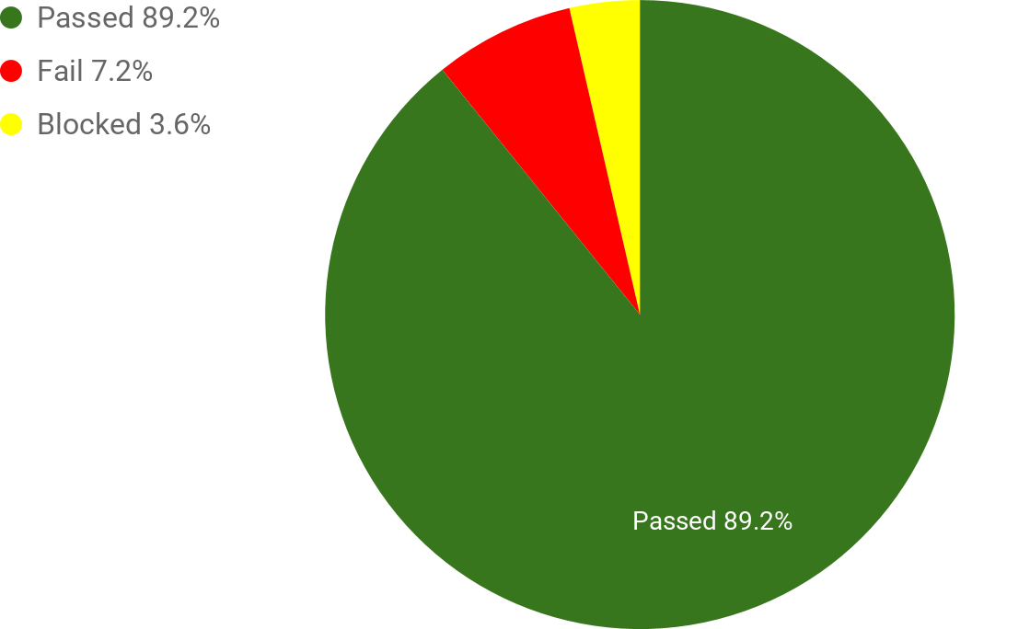

***Test results:***

|  |  |
| --- | --- |
| Overall | 28 / 100% |
| Passed | 25 / 89.2% |
| Failed | 2 / 7.2% |
| Blocked | 1 / 3,6% |
| Not Executed | 0 |

***Time used for executing 28 test cases (hours): 1 hour***

***Issues that were found (2):***

|  |  |  |
| --- | --- | --- |
| ID | Severity | Summary |
| FK-27 | Trivial | Ability of end user to delete all product from comparison on Comparison Page |
| FK-35 | Trivial | Ability of end user to continue shopping from comparison page |

**Conclusion:**

A few bugs. It’s normally for stable version.

For next Sprint i would recommend to improve the process of writing test-cases in some standart. For example IEEE829 for writing Test Plan.